Script-Controlled ACL
Customer Journey Map – Script-Controlled ACL – Restrict Record Access Based on Field Value
Persona: ServiceNow Administrator / Developer, with the service desk agent / end user as the affected user. Based on the Empathy Map and Problem Statements (PS-1 to PS-3) of the project team.
SCENARIO  Configuring, testing and using a script-controlled ACL to restrict record access based on a field value | Entice  How does someone initially become aware of this process? | Enter  What do people experience as they begin the process? | Engage  In the core moments in the process, what happens? | Exit  What do people typically experience as the process finishes? | Extend  What happens after the experience is over?
Steps  What does the person (or group) typically experience? | - Auditor or manager asks how access to sensitive records is restricted  - Administrator reviews the existing role-based ACLs on the table  - Finds that every role holder can see all records  - Decides record-level control based on a field value (e.g., Confidential) is needed | - Create the users and roles (Milestone 1)  - Create the table and the field that holds the restricted value (Milestone 2)  - Open a new ACL for the table and choose the operation | - Write the ACL script using current.<field>  - Set answer = true or false based on user role and field value  - Create READ, CREATE, WRITE and DELETE ACLs (Milestones 3–6)  - Test by impersonating users with different roles | - Verify that each role sees only the permitted records  - Confirm restricted records are hidden from lists and reports  - Review ACL evaluation order and system logs  - Share the results with the team leader | - Document the project outcome (Milestone 7)  - Reuse the ACL logic for other tables and fields  - Watch support tickets and logs for access issues  - Update scripts when roles or fields change
Interactions  What interactions do they have at each step along the way? | People: Manager, auditors, colleagues  Places: ServiceNow instance; audit review discussions  Things: ACL list, record lists, reports | People: Team leader and teammates  Places: Users & Groups, Tables and Access Control (ACL) modules  Things: User, role, table and ACL forms | People: Testers (through impersonation) and teammates  Places: ACL script editor, Impersonate User, System Logs  Things: ACL scripts, test records with a restricted value, log entries | People: Team leader, manager, auditors  Places: Record lists, reports and logs  Things: Test results and log evidence | People: End users, service desk agents, auditors  Places: Live instance and support queue  Things: ACL scripts, support tickets, audit reports
Goals & motivations  At each step, what is a person’s primary goal or motivation? (“Help me...” or “Help me avoid...”) | - Help me find where sensitive records are exposed  - Help me show who can see which record | - Help me set up a clean test environment quickly  - Help me choose the right ACL operation | - Help me allow or deny access correctly  - Help me avoid blocking legitimate users | - Help me confirm nothing leaks  - Help me show auditors how access is restricted | - Help me keep the rules correct as things change  - Help me reuse this logic elsewhere
Positive moments  What steps does a typical person find enjoyable, productive, fun, motivating, delightful, or exciting? | - Clear awareness of the gap before a data leak happens | - Setup tasks are easy (Milestones 1–2)  - Work is clearly divided among team members | - Results are visible straight away when impersonating a user  - Logic is reusable once the script works | - Confidence that only authorized users see restricted records  - Evidence is ready for audit | - Fewer support tickets about access issues  - Compliance and audit confidence
Negative moments  What steps does a typical person find frustrating, confusing, angering, costly, or time-consuming? | - Role-based ACLs expose every record in the table  - Colleagues say “just use role-based ACLs” | - Unsure how the ACL evaluation order works | - Scripts are hard to test and debug  - Fear of over-blocking or leaking data  - Script errors and hard-to-trace denials in logs | - Inconsistent results between users  - Users still say “I can’t open my own ticket!” | - Scripts may break when roles or fields change
Areas of opportunity  How might we make each step better? What ideas do we have? What have others suggested? | - How might we quickly list the tables whose records need field-based protection? | - Reuse one standard set of test users and roles for every ACL  - Keep a one-page note on ACL evaluation order | - Add log messages to ACL scripts to trace each decision  - Keep a test matrix of role × field value × operation | - Make sure record owners are never wrongly denied  - Produce a short test report for the auditors | - Use one reusable script pattern for any field value  - Review ACLs on a regular schedule

Project Design Phase-II
Data Flow Diagram & User Stories
Date | 31 January 2025
Team ID
Project Name | Script-Controlled ACL – Restrict Record Access Based on Field Value
Maximum Marks | 4 Marks
Data Flow Diagrams:
A Data Flow Diagram (DFD) is a traditional visual representation of the information flows within a system. A neat and clear DFD can depict the right amount of the system requirement graphically. It shows how data enters and leaves the system, what changes the information, and where data is stored.
Example: DFD Level 0 – Script-Controlled ACL
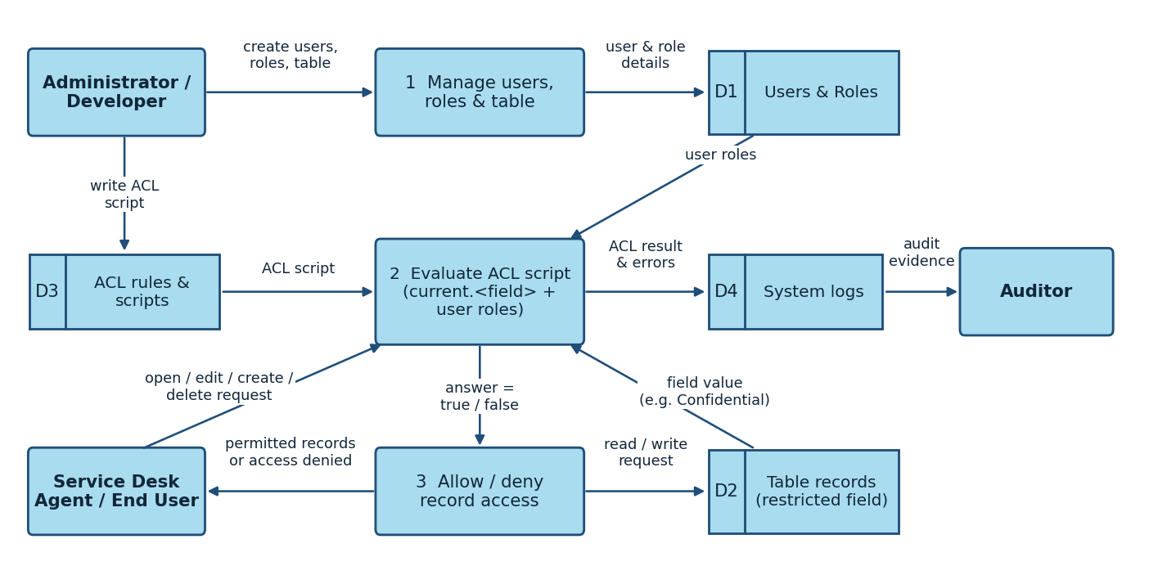
Flow
- The Administrator / Developer creates the users, roles and the table with the restricted field (Process 1, stored in D1).
- The Administrator / Developer writes the ACL script for READ, CREATE, WRITE and DELETE, which is stored as an ACL rule (D3).
- A service desk agent / end user requests to open, edit, create or delete a record.
- The ACL script is evaluated (Process 2): it checks the user’s roles (D1) and the record’s field value, current.<field> (D2).
- The script sets answer = true or false, and access is allowed or denied (Process 3).
- The ACL result and any script errors are written to the system logs (D4), which the Auditor can review.
User Stories
Use the below template to list all the user stories for the product.
User Type | Functional Requirement (Epic) | User Story Number | User Story / Task | Acceptance criteria | Priority | Release
Administrator | Users and Roles Creation | USN-1 | As an administrator, I can create users so that accounts exist for testing and using the access rules. | The users appear in the user list and can be impersonated. | High | Sprint-1
 |  | USN-2 | As an administrator, I can create roles and assign them to users. | The assigned roles are visible on each user record. | High | Sprint-1
 | Table Creation | USN-3 | As an administrator, I can create a table with a field that holds the restricted value (e.g., Confidential). | The table and field are available for records and for ACLs. | High | Sprint-1
Developer | ACL – READ | USN-4 | As a developer, I can write a script-controlled READ ACL that checks current.<field> and the user’s role. | Only authorized users can see records with the restricted value; others do not see them in forms or lists. | High | Sprint-1
 | ACL – CREATE | USN-5 | As a developer, I can create a CREATE ACL so that only authorized roles can create records. | Authorized users can create records; unauthorized users are blocked. | High | Sprint-2
 | ACL – WRITE | USN-6 | As a developer, I can create a WRITE ACL so that only authorized roles can edit restricted records. | Authorized users can edit; unauthorized users cannot change the record. | High | Sprint-2
 | ACL – DELETE | USN-7 | As a developer, I can create a DELETE ACL so that only authorized roles can delete restricted records. | Authorized users can delete; unauthorized users cannot. | Medium | Sprint-2
 | Testing and Verification | USN-8 | As a developer, I can test each ACL by impersonating different users and reading the system logs. | Results for each role and operation are checked, and script errors can be traced in the logs. | Medium | Sprint-3
Service Desk Agent / End User | Record Access | USN-9 | As a service desk agent, I can open the records I am authorized to see and work on. | Authorized records open without errors, and restricted records are not shown. | High | Sprint-2
 |  | USN-10 | As an end user, I can open my own records without being wrongly denied. | Record owners are not blocked by the ACL script. | High | Sprint-2
Auditor | Audit Evidence | USN-11 | As an auditor, I can see how access to restricted records is controlled. | The ACL scripts and test results show that restricted records are hidden from unauthorized roles. | Medium | Sprint-3

Project Design Phase-II
Solution Requirements (Functional & Non-functional)
Date | 31 January 2025
Team ID
Project Name | Script-Controlled ACL – Restrict Record Access Based on Field Value
Maximum Marks | 4 Marks
Functional Requirements:
Following are the functional requirements of the proposed solution.
FR No. | Functional Requirement (Epic) | Sub Requirement (Story / Sub-Task)
FR-1 | User and Role Creation | Create users  Create roles  Assign roles to users
FR-2 | Table Creation | Create the table  Add the field that holds the restricted value (e.g., Confidential)
FR-3 | ACL – READ | Create a script-controlled READ ACL  Check the user’s role and current.<field>  Set answer = true or false
FR-4 | ACL – CREATE | Create a script-controlled CREATE ACL  Allow only authorized roles to create records
FR-5 | ACL – WRITE | Create a script-controlled WRITE ACL  Allow only authorized roles to edit restricted records
FR-6 | ACL – DELETE | Create a script-controlled DELETE ACL  Allow only authorized roles to delete restricted records
FR-7 | Testing and Verification | Impersonate users with different roles  Review ACL evaluation order and system logs  Confirm record owners are not wrongly denied
Non-functional Requirements:
Following are the non-functional requirements of the proposed solution.
FR No. | Non-Functional Requirement | Description
NFR-1 | Usability | ACL rules and scripts are clear and easy to read and maintain, and a denied user gets a consistent result.
NFR-2 | Security | Only authorized users can see or change records with a restricted field value; access follows least privilege and is enforced on the server by the ACLs.
NFR-3 | Reliability | The same user, role and field value always give the same result, and the script handles empty or unexpected field values without errors.
NFR-4 | Performance | The script only checks the user’s role and the current record’s field value, so lists and forms keep loading quickly.
NFR-5 | Availability | The ACLs run on the ServiceNow cloud instance, so access control is enforced whenever the instance is available.
NFR-6 | Scalability | The same script pattern can be reused for other tables, fields and roles without redesign.

Project Design Phase-II
Technology Stack (Architecture & Stack)
Date | 31 January 2025
Team ID
Project Name | Script-Controlled ACL – Restrict Record Access Based on Field Value
Maximum Marks | 4 Marks
Technical Architecture:
The Deliverable shall include the architectural diagram as below and the information as per the table1 & table 2
Architecture: Script-Controlled ACL on ServiceNow
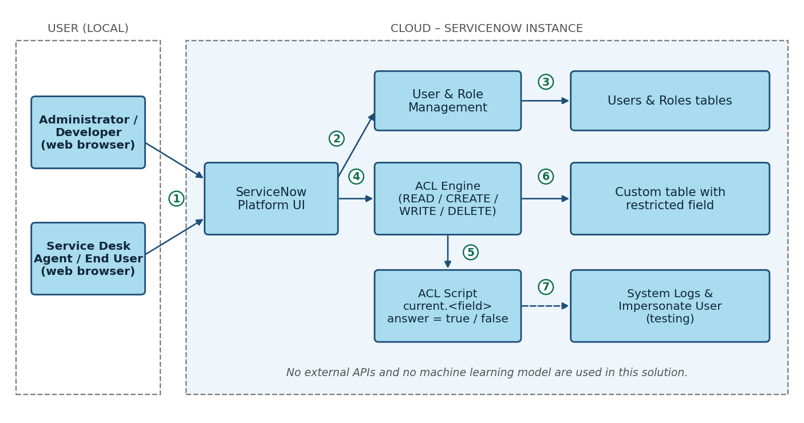
Flow
- The administrator, developer and end users open the ServiceNow Platform UI in a web browser.
- The Platform UI sends the user and role setup to User & Role Management.
- Users and roles are stored in the Users & Roles tables.
- Requests to read, create, write or delete a record go to the ACL Engine.
- The ACL Engine runs the ACL script, which checks current.<field> and sets answer = true or false.
- Only the permitted records from the custom table are returned to the user.
- Results and errors can be checked in System Logs, and testers use Impersonate User.
Table-1 : Components & Technologies:
S.No | Component | Description | Technology
1. | User Interface | How the administrator, developer and end user interact with the application: ServiceNow Platform UI in a web browser. | ServiceNow Platform UI (HTML, CSS, JavaScript in the browser)
2. | Application Logic-1 | Creation of users and roles and assigning roles to users. | ServiceNow user and role administration
3. | Application Logic-2 | ACL script that checks current.<field> and the user’s role and sets answer = true or false. | ServiceNow server-side JavaScript (ACL script)
4. | Application Logic-3 | ACL rules for the READ, CREATE, WRITE and DELETE operations and their evaluation order. | ServiceNow Access Control (ACL) engine
5. | Database | Custom table with the field that holds the restricted value, plus the users and roles tables. | ServiceNow platform database
6. | Cloud Database | Database service on the cloud: records are stored in the ServiceNow instance. | ServiceNow cloud instance
7. | File Storage | No separate file storage is required; the project works with records and ACL scripts only. | Not applicable
8. | External API-1 | No external API is used in this solution. | Not applicable
9. | External API-2 | No external API is used in this solution. | Not applicable
10. | Machine Learning Model | No machine learning model is used in this solution. | Not applicable
11. | Infrastructure (Server / Cloud) | Application deployment on cloud. Local Server Configuration: not applicable, no local server is used. Cloud Server Configuration: ServiceNow-hosted instance. | Cloud (ServiceNow instance)
Table-2: Application Characteristics:
S.No | Characteristics | Description | Technology
1. | Open-Source Frameworks | No open-source framework is added; the solution uses the native ServiceNow scripting. | ServiceNow server-side JavaScript
2. | Security Implementations | Role-based access plus script-controlled ACLs that check the record’s field value, least-privilege rules, testing with impersonation and review of system logs. | ServiceNow ACLs, roles, Impersonate User, System Logs
3. | Scalable Architecture | The same ACL script pattern can be applied to other tables and fields; the ServiceNow platform separates the browser, application and database tiers. | ServiceNow multi-tier cloud platform
4. | Availability | The ACLs are enforced on the server of the cloud-hosted ServiceNow instance, so they apply whenever the instance is available. | ServiceNow cloud instance
5. | Performance | Scripts stay short: they check only the user’s role and the current record’s field value and avoid extra database queries. | ServiceNow ACL scripts
References:
https://c4model.com/
https://developer.ibm.com/patterns/online-order-processing-system-during-pandemic/
https://www.ibm.com/cloud/architecture
https://aws.amazon.com/architecture
https://medium.com/the-internal-startup/how-to-draw-useful-technical-architecture-diagrams-2d20c9fda90d

